**COCA-COLA FINANCIAL REPORT DATA CURATION**

**A FOCUS ON THE CONSOLIDATED STATEMENT OF INCOME (2009 – 2019)**



Coca-Cola financial report is a voluminous document that contains the company’s financial report from 1990 to 2023 as at the time of this report. Each year of the report contains various financial reports such as the following:

1. Consolidated statements of income
2. Consolidated statements of comprehensive income
3. Consolidated balance sheets
4. Consolidated balance sheets balance sheet parenthetical
5. Consolidated statements of cash flows
6. Consolidated statements of shareowners' equity
7. Consolidated statements of shareowners’ equity shareowners' equity parenthetical
8. Business and summary of significant accounting policies
9. Acquisitions and divestitures
10. Revenue recognition
11. Investments
12. inventories
13. Hedging transactions and derivative financial instruments
14. Equity method investments
15. Property, plant and equipment
16. Intangible assets
17. Accounts payable and accrued expenses
18. Leases
19. Debt and borrowing arrangements
20. Commitments and contingencies
21. Stock compensation plans
22. Pension and other postretirement benefit plans
23. Income taxes
24. Other comprehensive income
25. Fair value measurements
26. Significant operating and non-operating items
27. Productivity and reinvestment program
28. Operating segments
29. Net change in operating assets and liabilities
30. Subsequent event
31. Business and summary of significant accounting policies (policies)

Aside the sections of the financial report listed above; there are still other sections which are tables such as *Operating segment tables* etcthat are not mentioned in the list above. The financial report was indeed voluminous.

**Data Curation**

The project focused on data curation and analysis of the Coca-Cola financial report’s **consolidated statement of income** only. The data was curetted by downloading, cleaning, merging and transforming 35 excel files for consolidate statement of account from December 2009 to December 2019.

The primary reason for focusing on the statement of income was that this part of the financial report will reveal the financial performance of the Coca Cola Company generally. Variables such as the revenues, the expenses, the gains and losses will be clearly shown by the statement of income. Insights on the company’s operations and management efficiency can also be gained through the income statement. For instance, if a particular operation yielded loss in a particular year did the loss increase or reduce the next year? Such insight can reveal management performance.

**PATTERN OF COCA-COLA FINANCIAL REPORT**

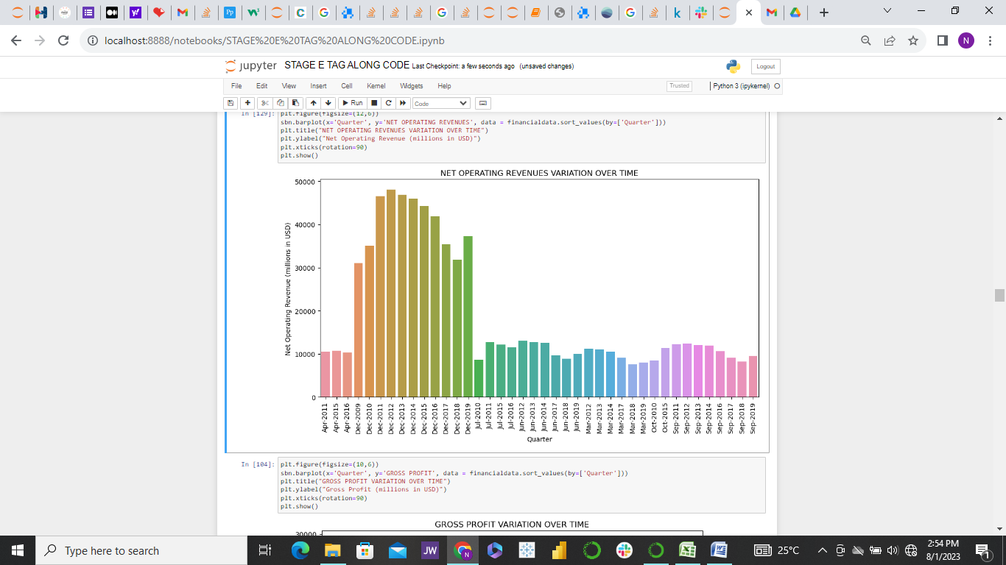

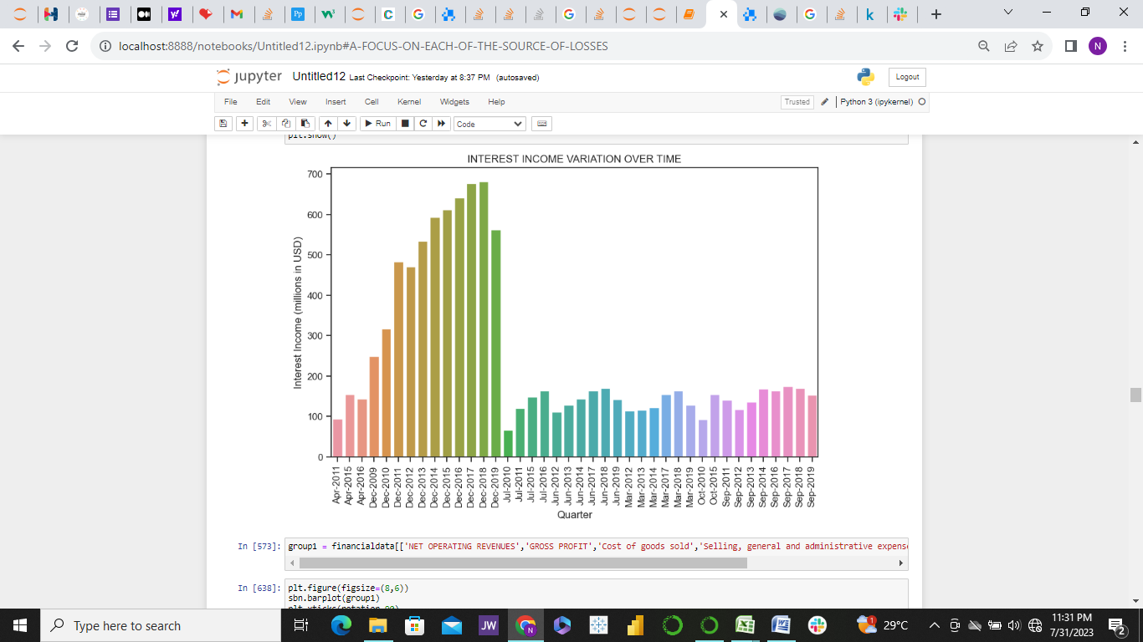

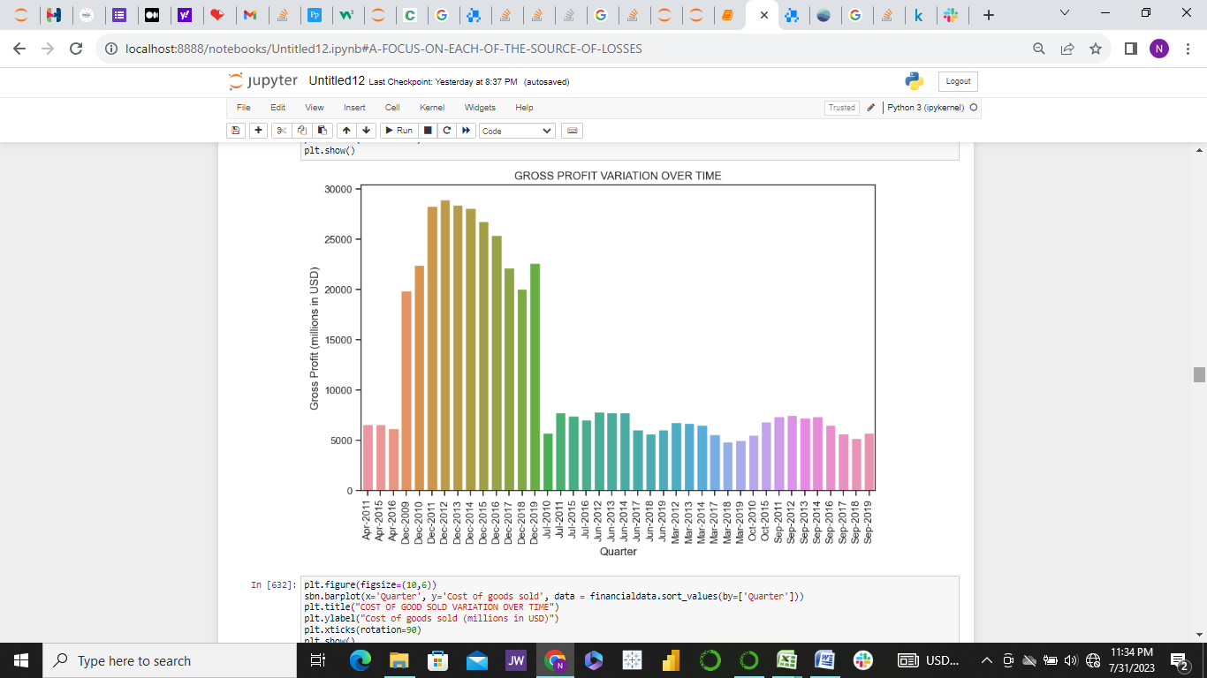

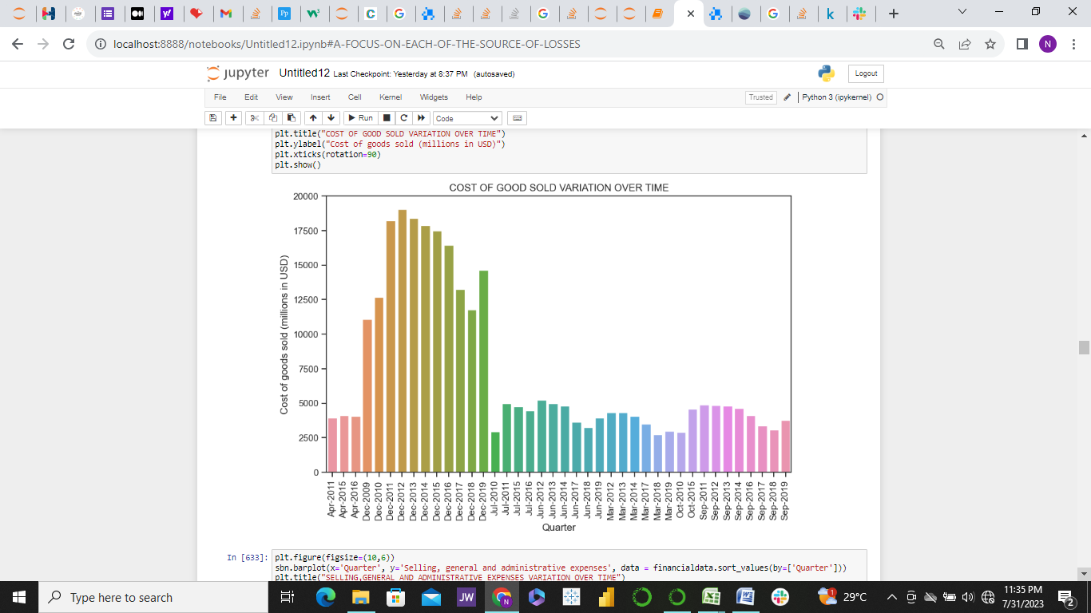

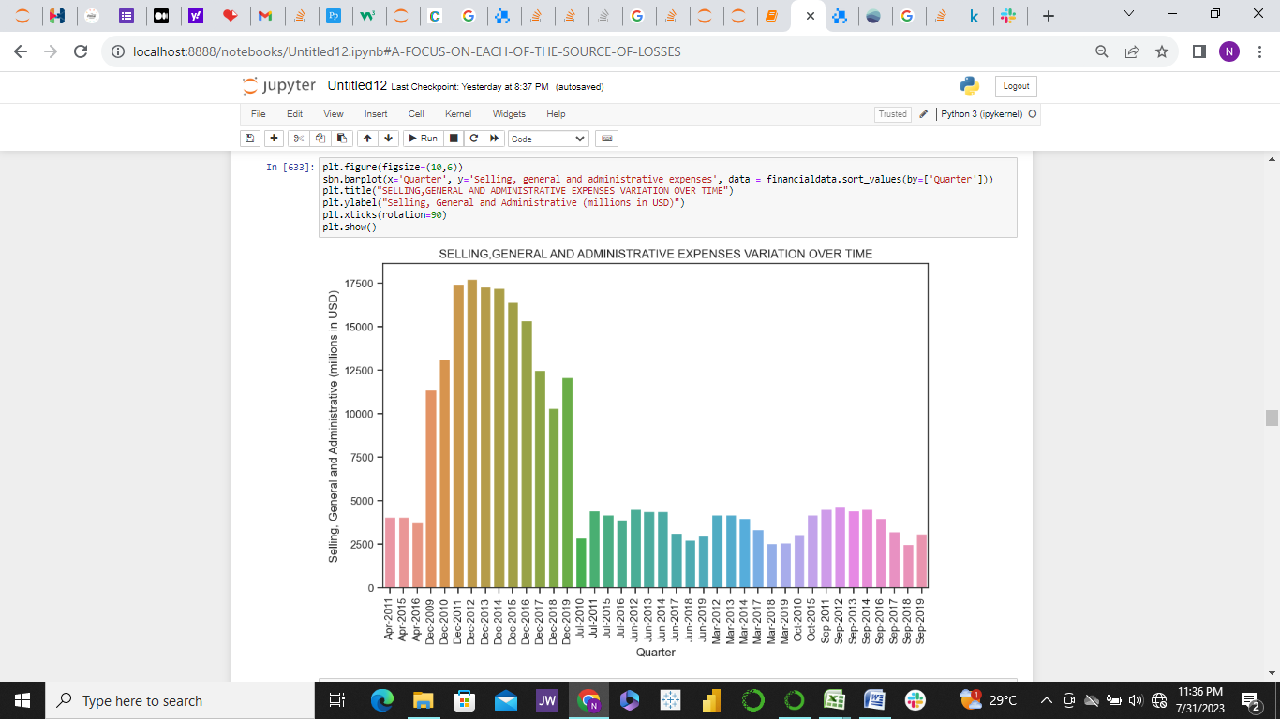

The figures above show variation of Net operating revenues, interest income, gross profit, Cost of goods sold, and Selling, general and administrative expenses variation over time. December was the peak period for each of the graphs shown in terms revenue generation, expenses and profit. This is not surprising because December is usually a festive season and most persons prefer software drink (which is Coca-Cola’s primary products) for occasions dues to its affordability, availability and general acceptance among the populace.

On the other hand, March and July seems to be the worse period for Coca Cola Company. This may not also be surprising because those months are often rain’s peak period. The weather of July may not make a cold bottle of soft drink as inviting as it would be during sunny and hot weather condition.

The consolidated net income which is the bottom line of the income statement, show the profit or income of Coca-Cola after removing taxes and adding any interest from shares. The graph below shows its behavior was regular like the graphs above, but was different for year 2017.

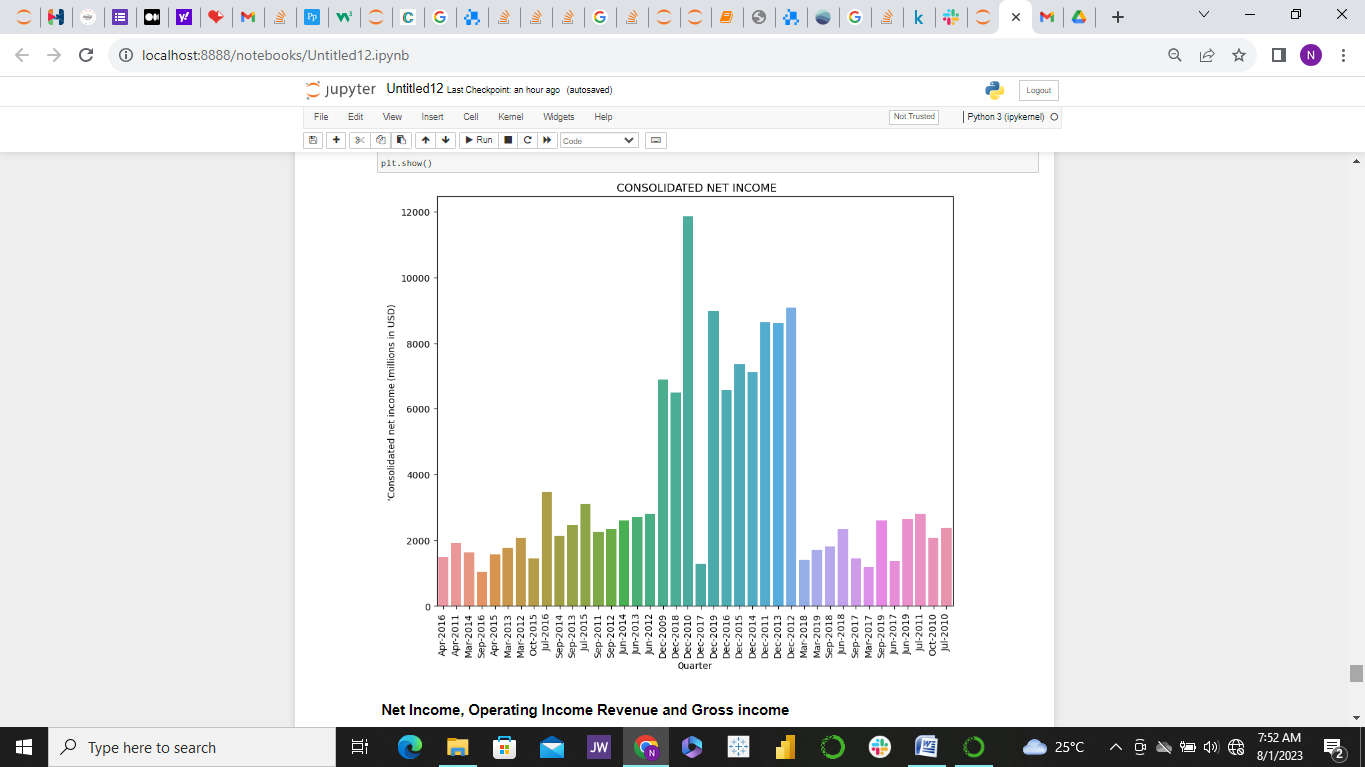

Many factors may have contributed the general decline in 2017 reports (especially December report despite having high revenue generation). As we examine the trends of various losses it will become clearer why the December decline happened.

The line graph below shows a comparative relationship among the Operating revenue, Gross profit, Cost of Goods, Operating income, and Net income at Coca Cola during the selected period.

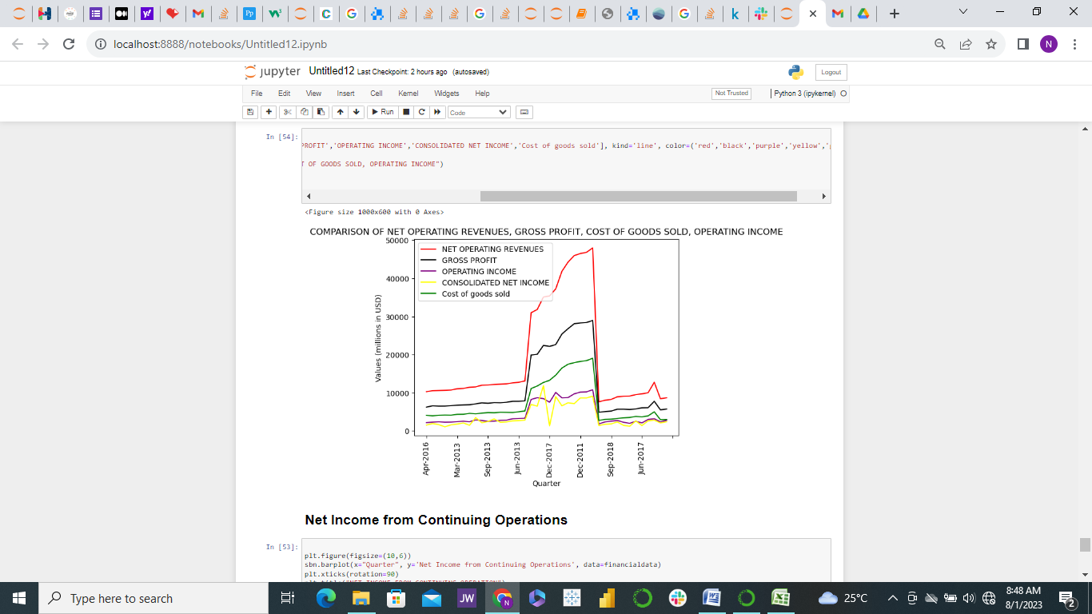

The line graphs show that Coca Cola Company often generates very high revenue from its operations. The red line shows the revenue or income generated from total sales over the period under consideration. December 2012 experienced the highest revenue generation of about USD48 billion. The black line is the gross profit which is the money at hand just after removing the cost of goods sold, which is the green line.

Just as expected, the purple line in below shows the operating income which is the income of the company after depreciation and paying off debts. The bottom income statement is right in yellow, this is actually the take-home income or net income of Coca-cola after removing other debts like other operation charges, lawsuit settling if any, adding shares generated if any and things of that nature. It can be noticed that the net income is very close with the operating income and there are few times the net income is even higher than the operating income.

This is quite understandable because when there are a lot of other operating charges and other issues like lawsuit cases, then one can expect net income to decrease more than operating income. On the other hand, when there are a lot of increases in the company’s share dividends, there will be increase in net income even above the operating income.

**Income Losses and There Sources**

Various sources of losses were captured in the income report. But one beautiful thing about these losses is that they could also mean profit when on positive side of the graph.

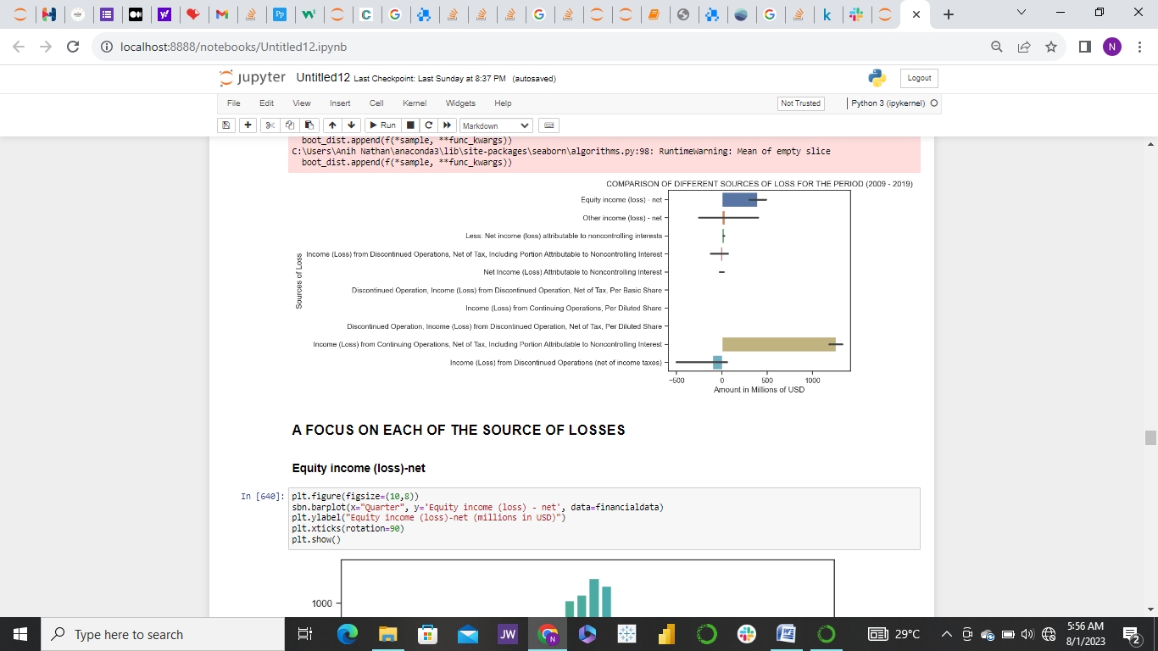

**A Close Look at each Potential Source of loss.**

**Equity Income (Loss) – Net**

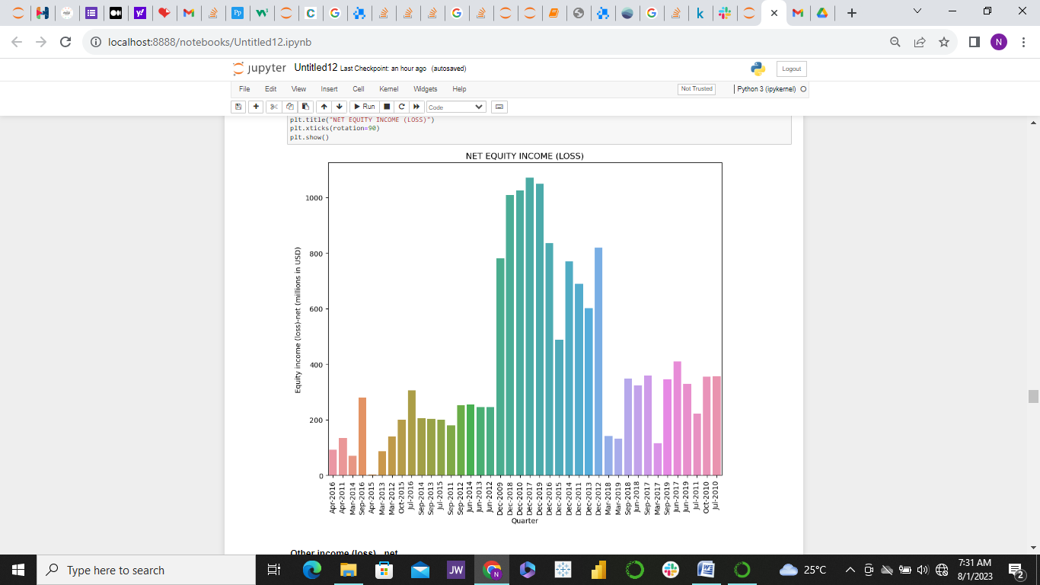

Interestingly there was no equity loss for the period from 2009 to 2022. Equity income comes for dividends of shares. So if share should go down it will be loss for the company and when it goes up then it means profit. It’s all profit for Coca- Cola Company, only in April 2015 did the company experience a very unusual low equity income.

**Other Income – Net**

Just like the equity income, this too was mostly profit than loss except for December 2017 when it was loss up to USD 1.5billion for Coca Cola.

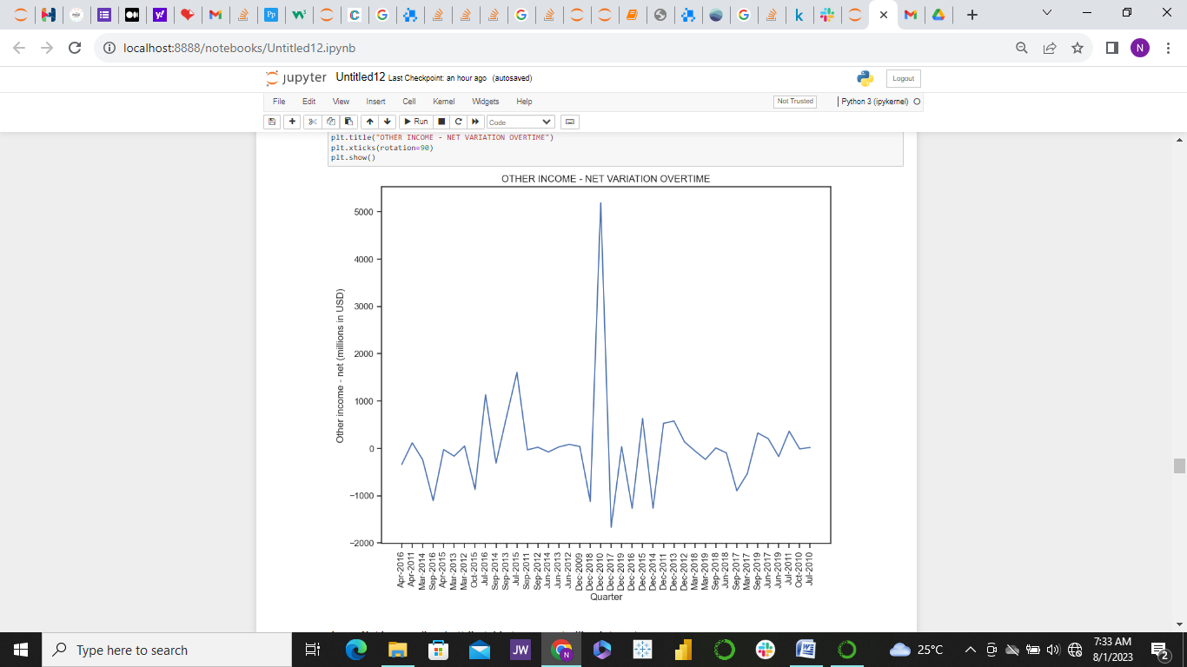

**Less: Net Income (Loss) Attributable to Non-controlling Interests**

This particular income was not captured for some of the quarters like December 2017. But it was mostly positive except for September 2019 when it was a loss of about USD2 million.

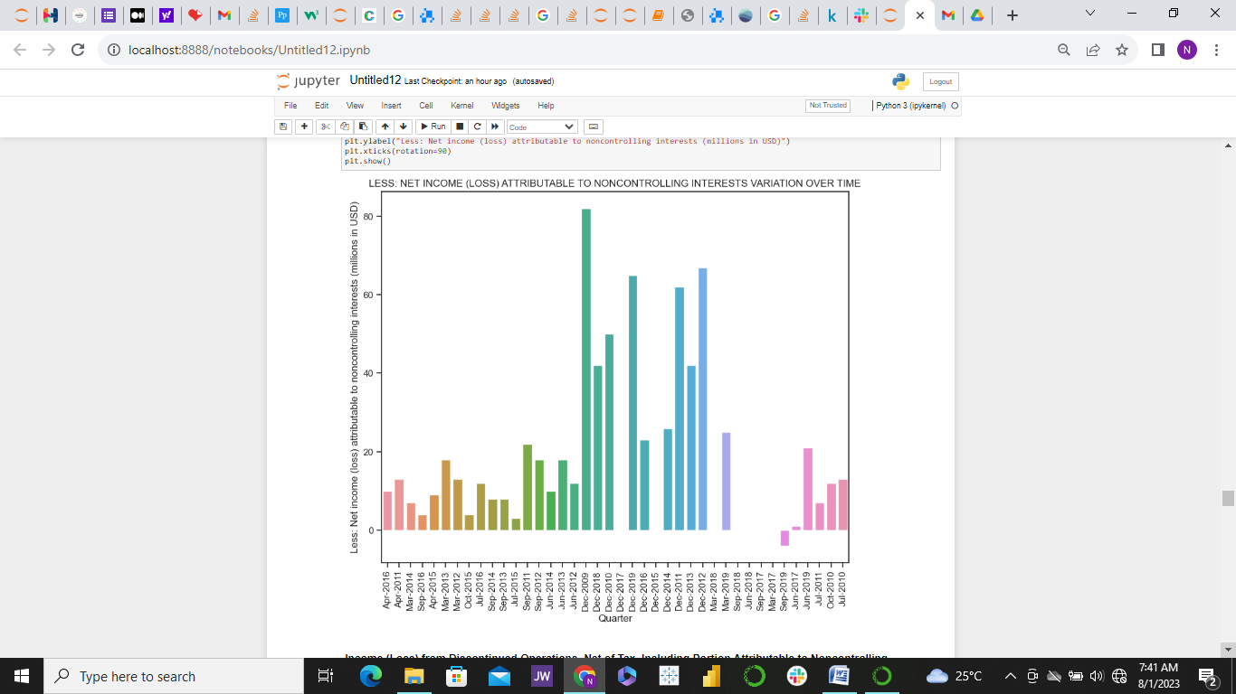

**Income (Loss) From Discontinued Operations, Net of Tax, Including Portions Attributable to Non-Controlling Interest**

The graph immediately below shows that the income from discontinued operation, including portions attributable to non-controlling interest was recorded thrice. Perhaps the operations concerned were very much in place during the periods it was not captured or they were ignored during record capturing which is most unlikely.

However, it seems December 2017 was likely the first time this operation was discontinued until end of March 2018, during this discontinued period the effect were positive income on the company. Then the operation continued and was again discontinued in December 2018. This time a huge loss of USD250 million was recorded, after which it seemed the company resolved to continue the operation, having recorded heavy loss for discontinuing the operation. This suggests that Coca Cola management is highly efficient in business management.

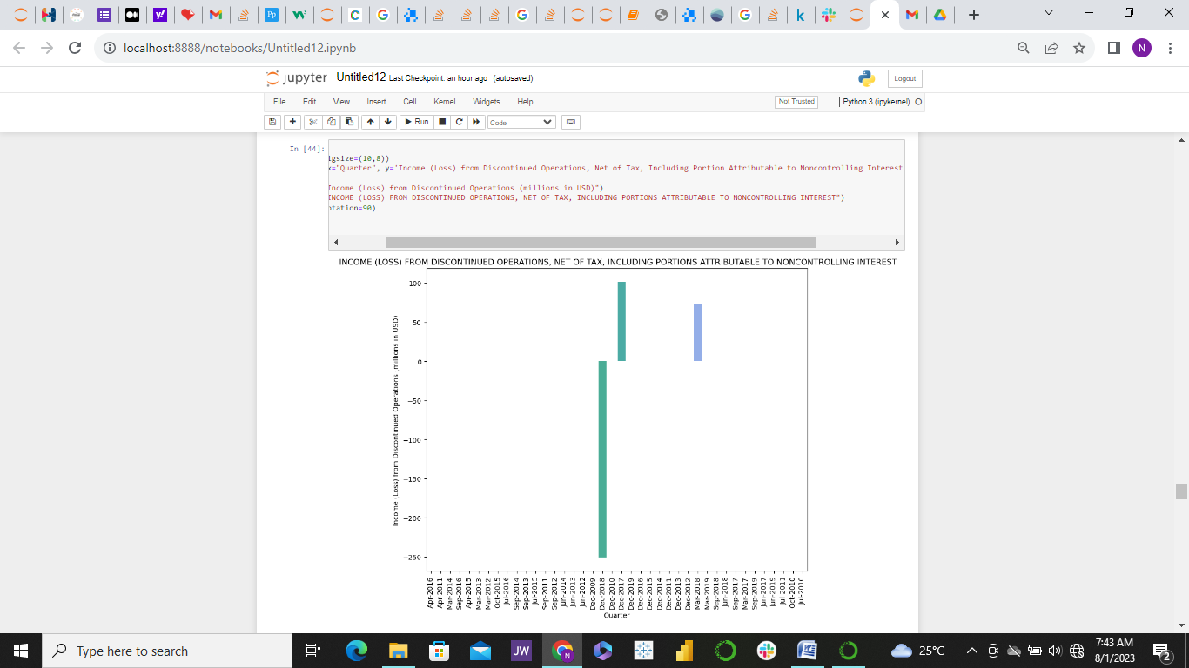

**Net income Loss Attributed to Non-controlling Interest**

This was recorded a few times. And the incomes were positive except for September 2018 when the company recorded a huge loss up to USD 60 million. And it can be noticed that it was not recorded again going forward. It seemed the company management immediately tackled the problem such ending such loss so far.

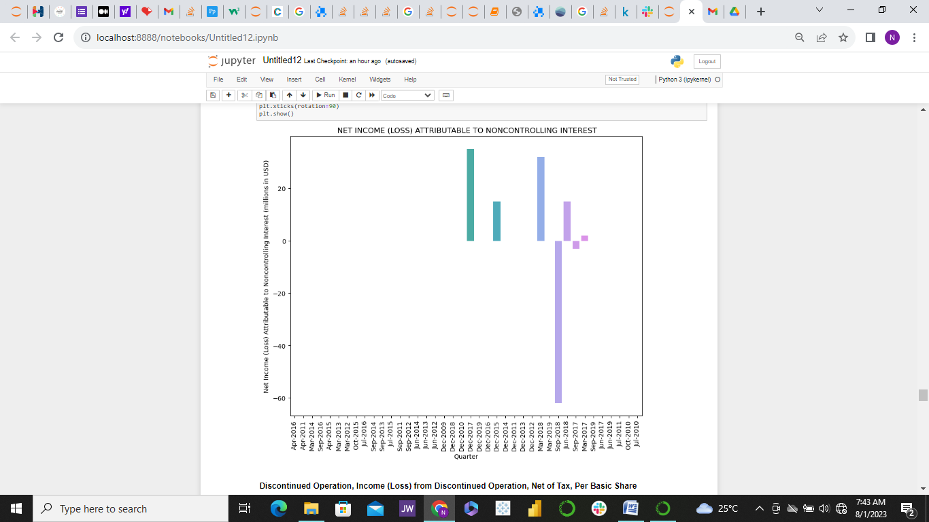

**Income (Loss) From Discontinued Operation, Net of Tax, Per Basic Share**

*Discontinued operation income per basic share* was recorded a few times. It was first recorded in December 2017. During September and December 2018 a great loss was suffered from this variable of about USD100 thousand and over USD70 thousand for September and December 2018 respectively. Reduction in loss suggests that coca cola management team took action against the loss.

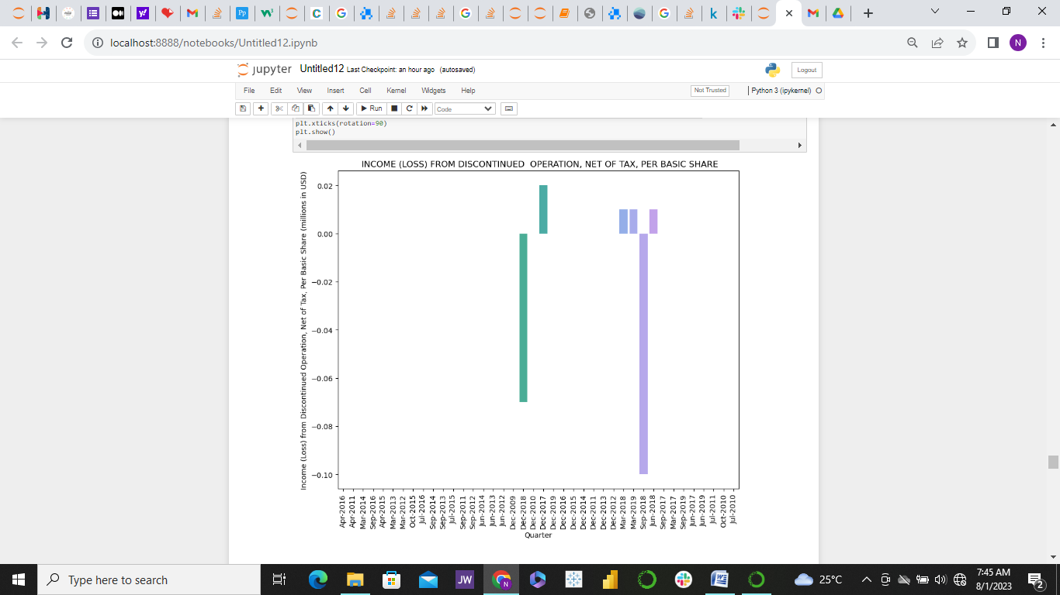

**Income Loss from Continuing Operations per Diluted Share**

Some operations continued by Coca-Cola Company are related to this income. It was recorded a few times as can be seen from the graph immediately below. And throughout the periods it was recorded, no loss was recorded for continuing the operations. The first time of continuing the operations in December 2015, there was a massive income generation above USD1.6 million, but it fluctuated over time. As at march 2019 the income generation was about USD 200 thousand.

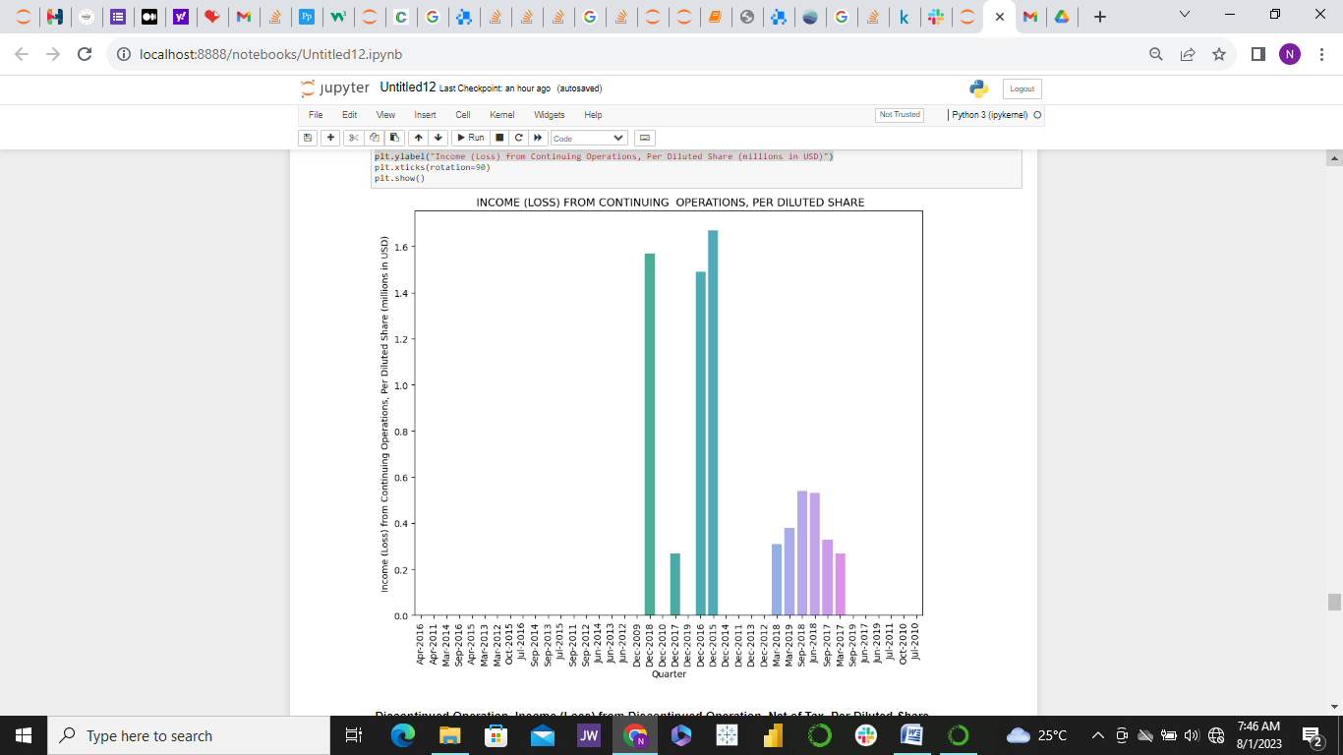

**Income (Loss) From Continuing Operations, Net of Tax, Non-Controlling Interest**

This was captured only twice in 2017 and 2018 respectively and perhaps likely discontinued. During the times captured it was all positive income, there was no single loss.

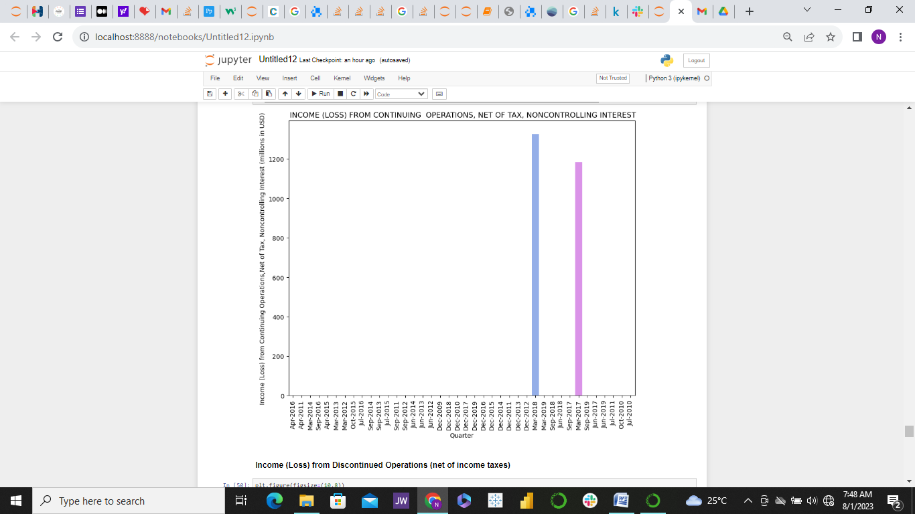

**Suggestions for other companies**

It was interesting to see how the company performance is so clear from the patterns seen in the graphs. Based on the observed patterns I will make the following recommendations for other companies I conduct financial analysis for.

1. Keep a clear record of your revenues, cost of good, Sells, general and administrative expenses. This will calculate your operating and net incomes. The net incomes tell a company the true value of what they really have.
2. Keep a record of the effect of any discontinued or continued operation. This can help inform the management if it is necessary to bring back such operation or scrap it for good
3. Keep a clear record of other expenses which are taken from net income and see how deeply it affects the business. For instance observe the graph the behavior of net income for December 2017.

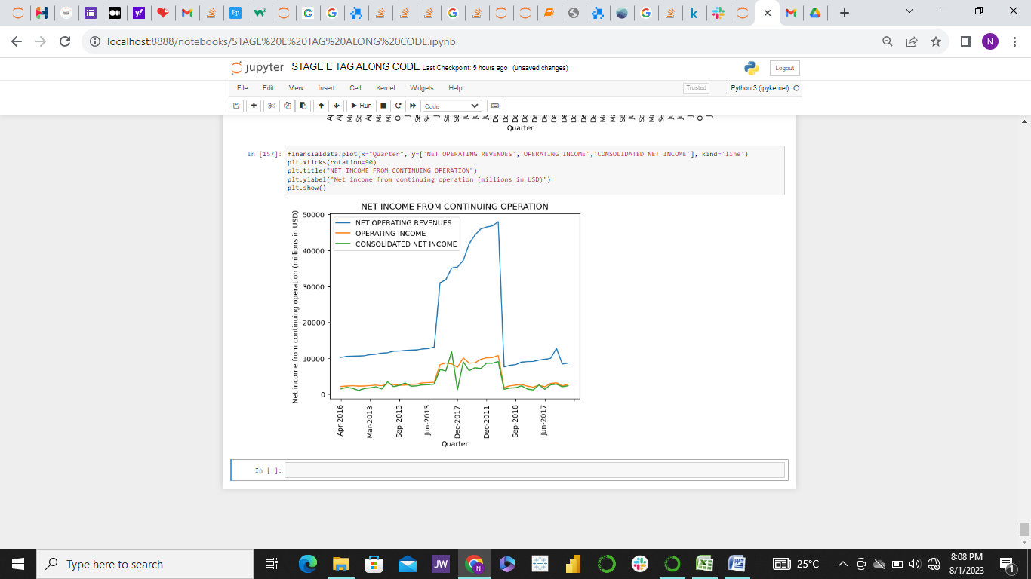

Despite the fact that the revenue generated was about USD35 billion USD and the operating income after removing all business running cost for the year was about USD 7.5 billion, it was observed that the net income for 2017 was only a little above USD 1billion. The reason for this can be seen from the *Other Operating Charges* graph below for the year the year 2017.

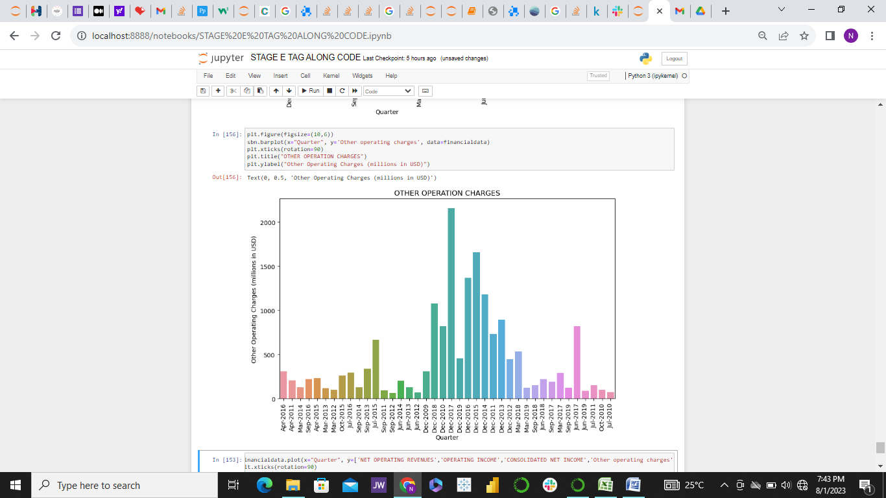

Notice how high the figure for *other operating charges* is for 2017. Although there are other things such as equity loss, foreign currency adjustment etc that contributed to the high reduction in net income for 2017, the greatest factor that contributed were the *other operation charges* which took away more than USD 2 billion from the net income for 2017

**Conclusion**

For proper accounting, companies are advised to ensure they keep record of every income flow in other to track when they are gaining or loosing. This will also help to track fraudulent activities. All who have access to funds at Coca Cola would have answered serious quarries in 2017 which a great reduction was observed in net income if not for proper record keeping consolidated income